Network Design Proposal
Biniyam Kebede
December 4, 2016
University of Maryland University College

- Physical Network Design

- Network Topology
Business Needs
The University Maryland University College has leased a building in Adelphi, Maryland. The building will consist of offices, classrooms, computer labs, and a library. Security is a main concern in regards to computer, employee and student information. UMUC would like to establish a secure network infrastructure within the building to support UMUC operations.
Proposed Topology
We propose a star topology design. With this every computer will be connected to a central switch with a point-to-point connection. Advantages include greater performance, simple connection of new nodes and/or devices and can be added without any downtime to the network, centralized network monitoring, and if a node fails there is no direct impact to the network.
STAR TOPOLOGY

End Device
Access Point
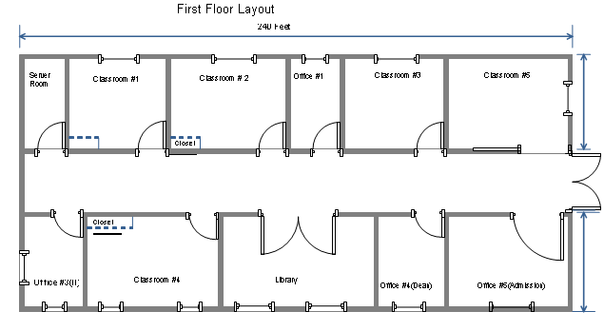
1 computer
1 computer
1 computer
1 computer
1 computer
21 computers
5 computers
13 computers
Server
Server
Server
Server
21 computers
21 computers

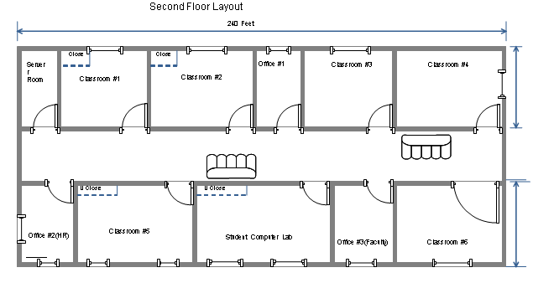
1 computer
1 computer
1 computer
WiFi Access Point

WiFi Access Point

Lobby
1 computer
30 computers
Server
Server
Server
Server
21 computers
21 computers
21 computers
Equipment | Cost
CAT6 Copper Wire (approx. 400ft) | $55.40
Cisco Firewall | $600.50
Tape Backup | $287.00
Windows Server 2012 | $6200.0
Log Management | $4,495.00
2 Managed L2 Core Switches | $2,530.00
5- 24 port Switches | $925.00
3- 48 port Switches | $897.00
2 Wireless Access Points | $185.98
8 Servers | $4000.00
175 Computers | $154,000.00
14 Network Printers | $4,466.00

The network will cost approximately $180,000 and will include such features as firewall, disaster recovery, log management, and file sharing.
Justification
Since the topology is the most common and suitable for this type of network I believe it will be the best option for client-server computing. It will provide the school with high performance and reliability (in the event of a failure will not affect others). With the use of a central hub/switch all computers and other equipment will connect to this central station to form a star formation.
- Network Media
Business Needs
When executing a new network infrastructure, we will consider the most ideal cabling for performance. All connections is to be performed utilizing physical links.
Proposed Network Media (include network wiring diagrams)
Propose using CAT6 copperwire for all connections.
NETWORK WIRING DIAGRAM :

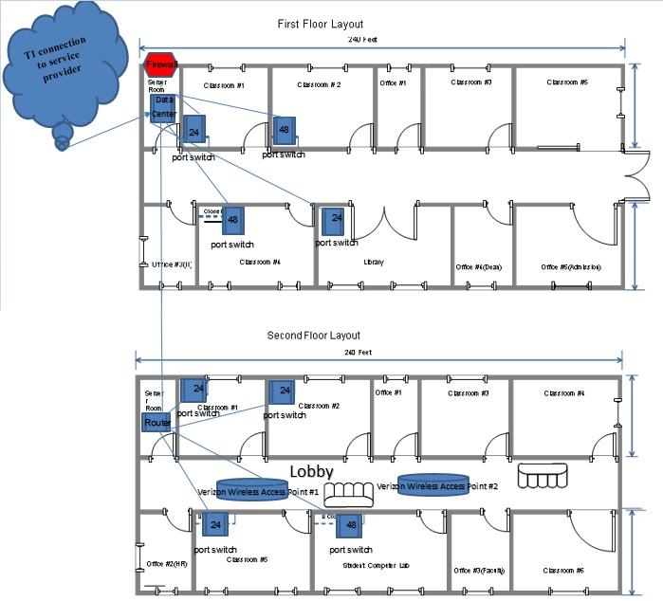
Justification
It would be suggested that Cat6 cabling is characterized as the Ethernet standard. There is no need for this network to require greater bandwidth than what the CAT6 cable would give, should be more economical than fiber optic. This is because of obvious constraints with Cat6 cabling, the most extreme link length that can be utilized to distribute linkage without transmission issues. Cat6A will consist of approximately 400ft of cabling to be utilized without bringing about any issues.

- Network Devices

Business Needs
Student, staff and public use computers should each have their own separate network. The whole building will share one T-1 link from Verizon, in addition to WiFi access in the student lobby.
Proposed Network Devices
I. Edge Core ECS4510-52T Managed L2 Switch. Quantity: 2. One will be located in the server room on the first floor, the second in the server room on the second floor.
II. LinkSys SE3024 24 port switches. Quantity: 5. The switches will be located on the first floor in Classroom #1 and the Library, the second floor in Classroom #1, #2 and #5.
III. NetGear FS750T2 ProSafe 48 port switches. Quantity: 3. The switches will be located on the first floor in Classroom #2 and #4, the second floor in Student Computer Lab.
IV. LinkSys N300 Dual Band WAP300N wireless access points. Quanity: 2. Both located in the student lobby on the second floor.
Justification
The proposed plan is based around a Star outline, keeping in mind the necessary links for each physical area and port. Having figured the quantity of connections required on every floor, it is evident that three 48 port switches and five 24 port switches will support the needed computers for each room on the first and second floors. It will convey the required number of links and take into account any expansion required, without expecting to add extra switches in the future. Should there be a need for increased network usage and computers, then the expansion of further switches as required would not be an excessively complex procedure.
- Network Security Devices
Business Needs
Security is a high priority and there will be a need to protect data and property on the servers and computers.
Proposed Network Security Devices
I. Cisco ASA 5520 Firewall. Quantity: 1. There will be one firewall located in the main server room on the first floor.
II. Quantum LTO-6 HH Tape Drive. Quantity: 1. There will be one firewall located in the main server room on the first floor.
Justification
Your school’s backup is of upmost value, implementing backup security is high priority. Installing affordable, authentic security backup strategies depends upon complete understanding of the associated trade-offs. To protect the data on servers and computers it would be in the schools best interest to invest in a firewall for network security and a tape drive for backup recovery with all in one data protection.
- Computer Systems
Business Needs
There is a network need for 8 servers to support 175 computers and 14 networked printers.
Proposed Computer Systems
I. Dell PowerEdge T20 Server- Xeon E3-1225V3 3.2 GHz – 4GB RAM – 1 TB HDD. Quantity: 8. The servers will be located on the first floor in Classroom # 1, #2 and #4. The rest will be located on the second floor in Classroom #1, #2, #5 and the Student Computer Lab.
II. Dell Inspiron One 23” Touch Screen All-in-one Intel Core i3 6GB Memory 1TB hard drive. Quantity: 175. Located in each room a computer is needed.
III. HP Jet Enterprise P3015dn Network printer. Quantity: 14. There will be 7 printers on each floor, the rooms with a higher need will have direct access.
Justification
The server room (main data center) located on the first floor will feed to the server room on the second floor. Both server rooms will feed to each server (closets) on their given floor. There will be switches to support all 175 computers and 14 networked printers in the building.
II. Network Addresses Design
- Subnetting
Business Needs
The network will use the 10.11.0.0/16 for all computers and devices, internet will use 151.1.1.1 address.
Proposed Subletting
Name | Network address | Broadcast address | Available IP addresses | Subnet Mask | IP addresses needed
Firewall to ISP | 10.11.1.0/30 | 10.11.1.3 | 10.11.1.1-10.11.1.2 | 255.255.255.252 | 1
Core switches | 10.11.1.4/30 | 10.11.1.7 | 10.11.1.5-10.11.1.6 | 255.255.255.252 | 2
Network switch management (VLAN 2) | 10.11.1.16/28 | 10.11.1.31 | 10.11.1.17-10.11.1.30 | 255.255.255.240 | 8
Classroom Student PC (VLAN 3) | 10.11.2.0/24 | 10.11.2.255 | 10.11.2.1-10.11.2.254 | 255.255.255.0 | 170
Computer Lab Student (VLAN 4) | 10.11.3.0/26 | 10.11.3.63 | 10.11.3.1-10.11.3.62 | 255.255.255.192 | 30
Admissions Office (VLAN 5) | 10.11.3.64/28 | 10.11.3.79 | 10.11.3.65-10.11.3.78 | 255.255.255.240 | 5
Library student PC's are part of VLAN 3
Library Staff (VLAN 6) | 10.11.3.80/29 | 10.11.3.87 | 10.11.3.81-10.11.3.86 | 255.255.255.248 | 3
Faculty (VLAN 7) | 10.11.3.96/27 | 10.11.3.127 | 10.11.3.97-10.11.3.126 | 255.255.255.224 | 17
Printers (VLAN 8) | 10.11.3.128/27 | 10.11.3.159 | 10.11.3.129-10.11.3.158 | 255.255.255.224 | 13
Servers (VLAN 9) | 10.11.3.160/28 | 10.11.3.175 | 10.11.3.161-10.11.3.174 | 255.255.255.240 | 10
Remaining addresses for 10.11.0.0/16
10.11.4.0-10.11.255.255

Justification
The network address design will meet the business needs because we separated the network into VLANS. All the student computers on a different VLAN from the staff computers VLAN. We propose a virtual separation of the different groups.

III. Network Services Design
- Network Services
Business Needs
Services that will enhance the needs and resources of the students and staff.
Proposed Network Services
I. Windows Server 2012 R2.
Edition: Datacenter
Virtual Rights: Unlimited
Licensing Model: Processor +, Client Access License
This particular license release is perfect for clients who need an exceptionally virtualized private and cloud environment. With each Windows Server 2012 R2 license it gives access to all features, allowing your cloud environment to develop as you do.
Justification
Windows Server 2012 for file sharing, print sharing and resource management which is ideal for small computing environments.
- Network Security Measures
Business Needs
Implement network training, monitoring and maintenance for data security.
Proposed Network Security Measures
I. Monitoring: Log Management Sever, Windows Server 2012
II. Training: Basic User Training w/ signed Acceptable Use Policy (AUP)
III. Maintenance: Tape Backup for disaster recovery
Justification
Windows Server 2012 will assist in the log management for all monitoring. All computer users will sign an Acceptable Use Policy (AUP) for network training purposes which will describe the rules and regulations set in place for the network and how it will be used. In the event of a total loss or power or resources, Tape Backup will allow all information to be recovered.

Reference
[1] Microsoft.com, 'Windows Server 2012 R2 overview | Microsoft', 2016. [Online]. Available: http://www.microsoft.com/en-us/server-cloud/products/windows-server-2012-r2/. [Accessed: 29- Oct- 2016].
[2] Teach-ict.com, 'Teach ICT - GCSE ICT - network topologies, network layouts, bus, ring and star networks', 2016. [Online]. Available: http://www.teach-ict.com/gcse_new/networks/topologies/miniweb/pg4.htm. [Accessed: 11- Nov- 2016].
[3]D. Black, 'Dell - Inspiron 23" Touch-Screen All-In-One - Intel Core i3 - 6GB Memory - 1TB Hard Drive - Black', Best Buy, 2015. [Online]. Available: http://www.bestbuy.com/site/dell-inspiron-23-touch-screen-all-in-one-intel-core-i3-6gb-memory-1tb-hard-drive-black/5858015.p?id=1219165148282&skuId=5858015. [Accessed: 11- Nov- 2016].
[4] Cisco, 'Building a Small Office Network', 2015. [Online]. Available: http://www.cisco.com/cisco/web/solutions/small_business/resource_center/articles/connect_employees_and_offices/primer_building_a_small_office_network/index.html. [Accessed: 12- Nov- 20156.
[5] ComputerWeekly, 'How to set up your small business computer network - Essential Guide', 2015. [Online]. Available: http://www.computerweekly.com/feature/How-to-set-up-your-small-business-computer-network-Essential-Guide. [Accessed: 30- Oct- 2016].

